EXPTNO :6(a) Implementation of Regression Model using linear regression

Aim

To Construct and Implement python program for regression model using linear regression.
Algorithm
- Import Libraries: Import necessary libraries like pandas, numpy, and sklearn.
- Load and Preprocess Data: Load the dataset, handle missing values (e.g., fill missing values with the median), and split it into features (X) and target (y).
- Train the Model: Use Linear Regression to train the model on the training data.
- Make Predictions: Use the trained model to predict prices for new data.
- Evaluate the Model: Calculate performance metrics like Mean Squared Error (MSE) and R-squared to evaluate the model.

Code:
import pandas as pd
fromsklearn import linear_model
fromsklearn.model_selection import train_test_split
fromsklearn.metrics import mean_squared_error, r2_score
# Load the dataset
df = pd.read_csv("C:\\Users\\Renuka\\Desktop\\AI ML LAB\\homeprice.csv")
# Strip any leading or trailing spaces from column names
df.columns = df.columns.str.strip()
# Data Preprocessing: Fill missing values with median value of the column
df['bedrooms'] = df['bedrooms'].fillna(df['bedrooms'].median())
df['Age (years)'] = df['Age (years)'].fillna(df['Age (years)'].median())
# Features and target
X = df.drop('Price ($)', axis='columns') # Features (Area, Bedrooms, Age)
y = df['Price ($)'] # Target (Price)
# Split the data into training and test sets
X_train, X_test, y_train, y_test = train_test_split(X, y, test_size=0.2, random_state=42)
# Create a linear regression model
reg = linear_model.LinearRegression()
# Train the model
reg.fit(X_train, y_train)
# Make predictions on the test set
y_pred = reg.predict(X_test)
# Model Evaluation: Mean Squared Error and R-squared
mse = mean_squared_error(y_test, y_pred)
r2 = r2_score(y_test, y_pred)
print(f'Mean Squared Error: {mse}')
print(f'R-squared: {r2}')# Model coefficients and intercept
print(f'Model Coefficients: {reg.coef_}')
print(f'Model Intercept: {reg.intercept_}'
# Make predictions on new data
new_data = [[3000, 3, 40]] # Example: 3000 sqrft, 3 bedrooms, 40 years old
predicted_price = reg.predict(new_data)
print(f'Predicted Price for 3000 sqrft, 3 bedrooms, 40 years old: {predicted_price[0]}')
# Another example: 2500 sqrft, 4 bedrooms, 5 years old
new_data_2 = [[2500, 4, 5]]
predicted_price_2 = reg.predict(new_data_2)
print(f'Predicted Price for 2500 sqrft, 4 bedrooms, 5 years old: {predicted_price_2[0]}')
Original Dataset:
Save it as csv file
Area (sqft) | bedrooms | Age (years) | Price ($)
2600 | 3 | 20 | 550000
3000 | 4 | 15 | 565000
3200 | 3 | 18 | 610000
3600 | 3 | 30 | 595000
4000 | 5 | 8 | 760000
4200 | 4 | 5 | 810000
2500 | 2 | 40 | 450000
2700 | 2 | 35 | 480000
3300 | 3 | 12 | 650000
3700 | 4 | 10 | 720000
4100 | 5 | 7 | 800000
2200 | 2 | 50 | 400000
2900 | 3 | 25 | 520000
3100 | 3 | 20 | 580000
3800 | 4 | 10 | 710000

Output:
Mean Squared Error: 1847518337.3775837
R-squared: 0.8918877435864873
Model Coefficients: [ 152.24076853 -5591.98289037 -3788.21617609]
Model Intercept: 205091.07412720926
Predicted Price for 3000 sqrft, 3 bedrooms, 40 years old: 493508.78400151443
Predicted Price for 2500 sqrft, 4 bedrooms, 5 years old: 544383.9830094788

Result:
Thus, the python program for linear regression model was executed successfully.

EXPTNO :6(b) Implementation of Regression Model using logisticregression
Construct and Implement python program for regression model using logistic regression.
AIM:

To Construct and Implement python program for regression model using logisticregression.
Algorithm
Step 1: Data Pre Processing
• Import necessary libraries.
• Import the dataset.
Step 2:Extracting Independent and dependent Variable
Identify the independent variables (features) and dependent variable (target).
Step3:Splitting the dataset into training and test set.
Use train_test_split to divide the data into training and test sets.
Step4:feature Scaling
Step5:Fitting Logistic Regression to the training set
Step6:Predicting the test set result
Step 2:Extracting Independent and dependent Variable
Step3:Splitting the dataset into training and test set.
Step4:feature Scaling
Step5:Fitting Logistic Regression to the training set
Step6:Predicting the test set result

Code:
import pandas as pd
frommatplotlib import pyplot as plt
fromsklearn.model_selection import train_test_split
fromsklearn.linear_model import LogisticRegression
import math

# Step 1: Importing the dataset
try:
df = pd.read_csv("C:\\Users\\Renuka\\Desktop\\AI ML LAB\\insurance.csv") # Replace with your actual dataset file path
print("Dataset preview:")
print(df.head()) # Print first few rows to ensure the data is loaded
exceptFileNotFoundError:
print("Error: The file 'insurance_data.csv' was not found. Please check the file path.")
exit()
# Step 2: Visualizing the data
plt.scatter(df['Age'], df['Bought insurance'], marker='+', color='red')
plt.xlabel('Age')
plt.ylabel('Bought Insurance (0 = No, 1 = Yes)')
plt.title('Age vs Bought Insurance')
plt.show()
# Step 3: Checking for necessary columns
if 'Age' not in df.columns or 'Bought insurance' not in df.columns:
print("Error: The dataset does not contain required columns 'Age' and 'Bought insurance'.")
exit()
# Step 4: Splitting the dataset into training and test sets
X_train, X_test, y_train, y_test = train_test_split(df[['Age']], df['Bought insurance'], train_size=0.8)
print("Test data preview:")
print(X_test.head()) # Ensure we have test data
# Step 5: Creating the Logistic Regression model
model = LogisticRegression()
model.fit(X_train, y_train)

# Step 6: Predictions and evaluation
y_predicted = model.predict(X_test)
print("\nPredicted values for test data:")
print(y_predicted)
# Model accuracy score
accuracy = model.score(X_test, y_test)
print(f"\nModel Accuracy: {accuracy:.2f}")
# Step 7: Predicted probabilities
print("\nPredicted probabilities for the test data:")
print(model.predict_proba(X_test)) # Show probabilities for test data
# Step 8: Coefficients of the model
print("\nModel coefficient (m):", model.coef_)
print("Model intercept (b):", model.intercept_)
# Step 9: Sigmoid function and manual predictions
def sigmoid(x):
"""Sigmoid function for logistic regression prediction"""
return 1 / (1 + math.exp(-x))
defprediction_function(age):
"""Function to predict probability for a given age"""
# Calculate the log-odds (z) for the logistic regression
z = model.coef_[0][0] * age + model.intercept_[0]
# Apply the sigmoid function to get the probability
y = sigmoid(z)
return y
# Step 10: Making manual predictions for certain ages
age = 35
pred_35 = prediction_function(age)
print(f"\nPredicted probability for age {age}: {pred_35:.4f}")
age = 43
pred_43 = prediction_function(age)
print(f"Predicted probability for age {age}: {pred_43:.4f}")
Dataset
Save it as csv
Age | Bought insurance
22 | 0
25 | 0
47 | 1
52 | 0
46 | 1
62 | 1
23 | 0
58 | 1
50 | 1
54 | 1

Output:
Dataset preview:
Age Bought insurance
0 22 0
1 25 0
2 47 1
3 52 0
4 46 1
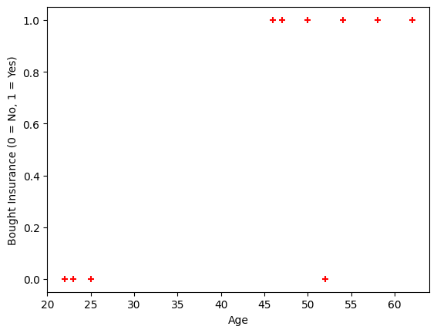
Test data preview:
Age
5 62
8 50
Predicted values for test data:
[1 1]
Model Accuracy: 1.00
Predicted probabilities for the test data:
[[0.04212471 0.95787529]
[0.23893469 0.76106531]]
Model coefficient (m): [[0.16379618]]
Model intercept (b): [-7.03128012]
Predicted probability for age 35: 0.21443209738034713
Predicted probability for age 43: 0.5029888835347912

Result:
Thus, the python program for logistic regression model was executed successfully.
EXPTNO :7 (a) Implementation of Decision Tree
Construct python program Decision tree using Gaussian mixture model.

Aim:
To Construct python program Decision tree using Gaussian mixture model and visualize graph .
Procedure:
1. Required libraries, namely pandas, numpy, matplotlib, and scikit-learn with the modules for preprocessing, clustering, classification and evaluation, are imported.
2. The dataset is loaded into the local directory.
3. For the data preprocessing, the label encoder is performed.
4. For feature scaling, a standard scaler is performed.
5. The target variables are set.
6. Next, the dataset was separated into input features (X) and output labels (y) minus the target and the original Confirmed column.
7. Train-test split was performed.
8. Train a decision tree classifier on the training data so that the limit on depth (e.g., max_depth=5) is imposed to limit overfitting and recursion error.
9. A visual plot of the trained decision tree can be displayed using plot_tree() from scikit-learn.
Code:
import pandas as pd
import numpy as np
import matplotlib.pyplot as plt
import seaborn as sns
from sklearn.preprocessing import LabelEncoder, StandardScaler
from sklearn.mixture import GaussianMixture
from sklearn.tree import DecisionTreeClassifier, plot_tree
from sklearn.model_selection import train_test_split
from sklearn.metrics import classification_report, accuracy_score
# Load data
data = pd.read_csv('/content/covid_19_india.csv')
# Drop unnecessary columns
data.drop(['Sno', 'Date', 'Time'], axis=1, inplace=True)
# Label Encoding & conversion
le = LabelEncoder()
data['State/UnionTerritory'] = le.fit_transform(data['State/UnionTerritory'])
data['ConfirmedIndianNational'] = pd.to_numeric(data['ConfirmedIndianNational'], errors='coerce').fillna(0).astype(int)
data['ConfirmedForeignNational'] = pd.to_numeric(data['ConfirmedForeignNational'], errors='coerce').fillna(0).astype(int)
# Standardize the data
scaler = StandardScaler()
scaled_data = scaler.fit_transform(data)
# Step 1: Apply Gaussian Mixture Model
gmm = GaussianMixture(n_components=3, random_state=0)
gmm_labels = gmm.fit_predict(scaled_data)
# Add GMM cluster labels as new column
data['GMM_Cluster'] = gmm_labels
# Step 2: Create a label for classification (e.g., Confirmed cases categories)
# Categorize confirmed cases into 3 classes: Low, Medium, High
def case_category(x):
if x < 100:
return 0 # Low
elif x < 1000:
return 1 # Medium
else:
return 2 # High

data['CaseCategory'] = data['Confirmed'].apply(case_category)
# Prepare features and label
X = data.drop(['Confirmed', 'CaseCategory'], axis=1)
y = data['CaseCategory']
# Train-test split
X_train, X_test, y_train, y_test = train_test_split(X, y, test_size=0.3, random_state=42)
# Step 3: Decision Tree Classifier
dt_model = DecisionTreeClassifier(max_depth=5, random_state=42)
dt_model.fit(X_train, y_train)
# Predict and evaluate
y_pred = dt_model.predict(X_test)
print("Accuracy:", accuracy_score(y_test, y_pred))
print("Classification Report:\n", classification_report(y_test, y_pred))
# Step 4: Visualize the decision tree
plt.figure(figsize=(16, 10))
plot_tree(dt_model, feature_names=X.columns, class_names=['Low', 'Medium', 'High'], filled=True)
plt.title("Decision Tree Using GMM Cluster Feature")
plt.show()

Output:
Accuracy: 0.9823302043070127
Classification Report:
precision recall f1-score support

0 0.93 0.99 0.96 498
1 0.87 0.85 0.86 345
2 1.00 0.99 0.99 4590

accuracy 0.98 5433
macro avg 0.93 0.94 0.94 5433
weighted avg 0.98 0.98 0.98 5433

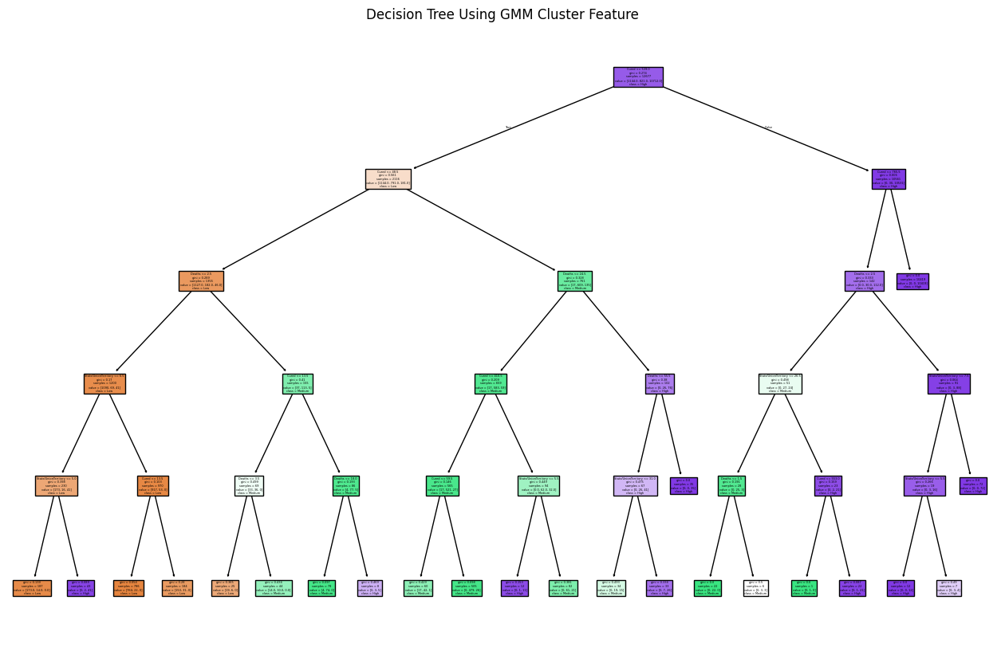

Result:
Thus the python program for Decision tree using Gaussian Mixture Model was executed successfully

EXPTNO :7 (b) Implementation of Random Forest Tree.

Construct python program for random forest tree and build the model
Aim:
ToConstruct python program for random forest tree and build the model .
Procedure:
- Import the necessary libraries like pandas, sklearn, and matplotlib.
- We use the Iris dataset here for simplicity. Replace it with your dataset (using pd.read_csv() for CSV files).
- We separate the dataset into independent variables (features) and dependent variable (target). Split the data into training and testing sets (80-20 split in this case).
- Initialize the RandomForestClassifier and train it with the training data.
- Use the trained model to predict values for the test data.
- We evaluate the model using accuracy score and a classification report.
Code:
# Step 1: Importing the necessary libraries
import pandas as pd
fromsklearn.ensemble import RandomForestClassifier
fromsklearn.model_selection import train_test_split
fromsklearn.metrics import accuracy_score, classification_report
fromsklearn.datasets import load_iris
importmatplotlib.pyplot as plt

# Step 2: Load a dataset (using Iris dataset as an example here)
# You can replace this with your own dataset
data = load_iris()
df = pd.DataFrame(data.data, columns=data.feature_names)
df['target'] = data.target

# Step 3: Extracting Independent and Dependent Variables
X = df.drop(columns=['target']) # Independent variables (features)
y = df['target'] # Dependent variable (target)

# Step 4: Splitting the dataset into Training and Test sets
X_train, X_test, y_train, y_test = train_test_split(X, y, test_size=0.2, random_state=42)

# Step 5: Fitting the Random Forest Classifier to the Training Set
model = RandomForestClassifier(n_estimators=100, random_state=42)
model.fit(X_train, y_train)

# Step 6: Predicting the Test Set Results
y_pred = model.predict(X_test)

# Step 7: Evaluating the Model
accuracy = accuracy_score(y_test, y_pred)
print(f"Accuracy: {accuracy * 100:.2f}%")
print("Classification Report:")
print(classification_report(y_test, y_pred))

# Optional: Visualizing feature importance
plt.barh(X.columns, model.feature_importances_)
plt.xlabel('Feature Importance')
plt.ylabel('Feature')
plt.title('Random Forest Feature Importance')
plt.show()

Output:

Accuracy: 100.00%
Classification Report:
precision recall f1-score support

0 1.00 1.00 1.00 10
1 1.00 1.00 1.00 9
2 1.00 1.00 1.00 11

accuracy 1.00 30
macroavg 1.00 1.00 1.00 30
weightedavg 1.00 1.00 1.00 30

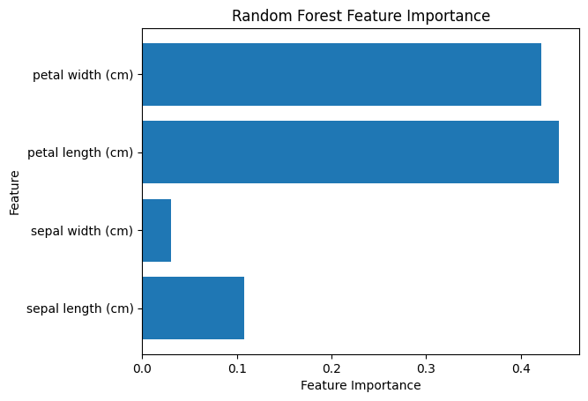

Result

Thus, the python program for random forest tree was executed successfully

